**ASI Steel Sustainability Awards – Entry Form**

**Category 5: People – Rising Star in Steel Sustainability**

***To be uploaded to the online*** [***ASI Steel Sustainability Awards entry portal***](https://www.steel.org.au/sustainability-awards/)

*Recognising leadership in driving positive sustainability outcomes using steel solutions in the Australian built environment.*

**CATEGORy 5 ENTRY REQUIREMENTS – ALL FIELDS ARE MANDATORY AND MUST BE COMPLETED**

1. Nominated person must be 25yrs of age or under for Category 5 at the close of the entry date.
2. Nominated person must be employed in the Australian steel supply chain or associated industries

**Contact Details of the person submitting this award entry:**

|  |  |
| --- | --- |
| Company Name |  |
| Contact First Name |  |
| Contact Last Name |  |
| Contact Email Address |  |
| Contact Phone Number |  |

**Details of Nominee**

|  |  |
| --- | --- |
| Company |  |
| Type of business in the steel supply chain |  |
| Nominee’s First Name |  |
| Nominee’s Last Name |  |
| Nominee’s Email Address |  |
| Nominee’s Phone Number |  |
| Age and Date of Birth |  |

**CATEGORY 5 WEIGHTED EVALUATION CRITERIA – COMPLETE AND PROVIDE EVIDENCE FOR EACH CRITERIA BELOW.**

*Judges will assess nominees against the following criteria and provide a holistic score out of 100.*

1. How does the nominee demonstrate skills and knowledge in steel sustainability? This must be demonstrated clearly in at least two or more of the following areas: knowledge of core sustainability principles; sustainability in design; the circular economy in the built environment; managing out waste; carbon accounting, measurement and reporting; global best practices.

**Files names of supporting documents/files uploaded:**

**Response to criteria:**

1. How has the nominee demonstrated keen ambition for sustainability in the steel industry?

**Files names of supporting documents/files uploaded:**

**Response to criteria:**

**Response to criteria:**

1. What future aspirational plans does the nominee have for steel sustainability?

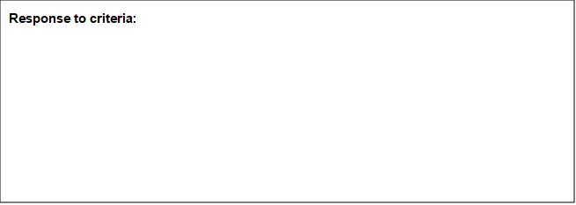

**Text Box**